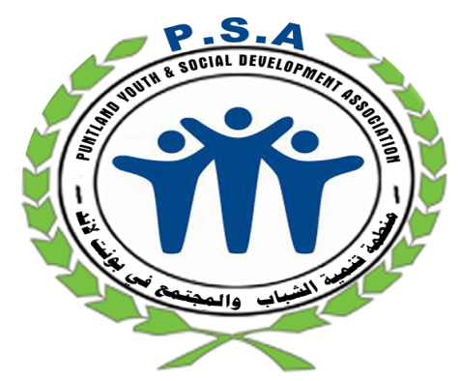
2017

PUNTLAND YOUTH AND SOCIAL DEVELOPMENT ASSOCIATION
PSA

ANNUAL REPORT

Contacts:
Abdifatah MohamedSugulle, Executive Director-PSA
Head offices: Bosaso, Puntland, Somalia
Tel: +25290-7796609/ 252907791392; E-mail: Abdifitah@psasomalia.org
Facebook: www.facebook.com/psasom ; Skype: abdisugulle1

Table of Contents
Acronyms and abbreviations 3
Acknowledgement 4
Executive Summary 5
1.0. INTRODUCTION 6
2.0. PROGRAMME ACHIEVEMENTS 6
2.1 Protection Programme 6
Child Protection(CAAFAG) 6
Gender Based Violence (GBV) Programme 15
FGM/C forum group 15
16-Days activism 16
2.2 Livelihood 16
Global Entrepreneurship Week (GWE) 16
2.3 Health 17
World’s Aids day 17
IYCF Program ………………………………………………………………………………………………………………………………………………… 17
2.4 Capacity Building 17
Youth Leadership Capacity Building 17
Staff capacity building 18
Monthly Youth Forum 18
2.5 Micro-Assessment 18
2.6 Advocacy Programme 19
Somalia Independence Day Commemoration 19
Somali National Youth Day Commemoration 19
Establishment of Puntland state (1st August) Commemoration 19
Eradication of violence against women day (25th November) Commemoration 19
International Women’s Day Commemoration 19
Human rights day Commemoration 20
2.7 Media 20
LESSONS LEARNT 21
CHALLENGES 21

Acronyms and abbreviations

BYC : Bosaso Youth Centre
CPC : Child Protection Committees
CRC : Child Rights Clubs / Child Rights Committees
FGM/C : Female Genital Mutilation/Cutting
GBV : Gender Based Violence
GEWE : Gender Equity and Women Empowerment
HIV : Human Immune Virus Syndrome
HRAP : Human Rights Approach to Programming
ICT : Information, Communication Technology
IDP : Internally Displaced Persons
IEC : Information, Education and Communication
INGO : International Non-Government Organization
IWD : International Women's Day
LNGO : Local Non-Government Organization
LSBE : Life Skills Based Education
IYCF : Infant Young and child feeding
MOE : Ministry of Education
MOWDAFA : Ministry of Women Development and Family Affairs
M&SS : Monitoring and Support Supervision
NFE : Non Formal Education
PAC : Puntland Aids Commission
PAHCO : Puntland Aid for Homeless Children Organization
PLWA : People living with AIDS
PMN : Protection Monitoring Network
PSA : Puntland Youth and Social Development Association
PSS /PST : Psychosocial Support / Psychosocial Therapy
RECEIVE : Relevant, Efficient, Coordinated, Effective, Impactful & Empowered
SBC : Somali Broadcasting Corporation
SMS : Short Message Sending
TOT : Training of Trainers
UNDP : United Nations Development Programme
UNHCR : United Nations High Commission for Refugees
UNICEF : United Nations Children's Fund

Acknowledgement

‘’Those who are in a position of strength have a responsibility to protect the weak’’

The year 2017 has been significant for Puntland Youth and Social Development Association (PSA). On behalf of the Board of directors I can say that, while there will always be considerable work to do and challenges to face, P S A is in a strong position in rolling out programmes and projects that aid in transforming and changing lives across Puntland-Somalia.

Building on the momentum of previous years, I am proud to say that PSA has tirelessly implemented and advocated for projects on the six key areas under our strategic plan: Reconciliation and Peace building, child protection, human rights , gender and Protection of the girl-child and women, improved livelihoods through micro-loans and training, support to the education sector, health promotion including water and sanitation and Infrastructural development and renovation. One of our biggest accomplishments in 2017 is implementation of CAAFAG and IYCF projects, we had the great pleasure of working with various individuals in the field and it was perfect opportunity to hear and see the issues affecting communities in the region.

This year we also worked hard to influence policy-makers. We put forward submissions to a number of inquiries, such as the Inquiry into Child Protection, Inquiry into Migrant Settlement Outcomes and the community empowerment programmes. The success of this advocacy helps put youth issues on the political agenda.

There is still so much to be done to make Puntland and Somalia a better place. I am proud of the steps we have taken, and excited for the challenges ahead of us.

As executive director am honoured to work with such an exceptional team, strong partners, and passionate member base, We thank all our partners; UNICEF, WFP, UNHCR, government and all other agencies for their continued support through funding, support and cooperation. Thank you again for standing with us in 2017.

Abdifittah Mohamed Sugule
EXECUTIVE DIRECTOR

Executive Summary
Our Annual Report provides an overview of the work of Puntland Youth and Social Development Association (PSA) in 2017 fiscal year.

Our projects fall under six (6) programmes, namely: child protection, gender-based violence (GBV), livelihood programme, health program, youth empowerment and humanitarian support, awareness raising campaigns were also part of the activities including international days that we commemorated; in addition PSA entered partnership with various funders in extending its scope of operations. The document serves to give a summary picture of what transpired over the year. The main report is divided into 5 sections: Introduction, Programme achievements, Lessons learnt, challenges then conclusions and recommendations.

Under child protection, PSA implemented CAAFAG project which is a rehabilitation of former children associated with armed groups, the second major project was implementing exclusive breastfeeding/IYCF project in Bosaso which prioritize in building awareness and inspires action for improved nutrition, on GBV we conducted 16 days activism involvement and held FGM/C workers forum monthly meetings. Under the livelihoods programme, PSA submitted proposals on the food-for-asset -FFA (cash voucher) and FFT (Food for Training) which were successful and implementation will start in January 2018. Under the health programme, the focus was on HIV/AIDS awareness and sensitization. Lastly as the norm, PSA provided support to needy individuals and households over the month of Ramadhan.

Our programs continue to be based on a holistic approach, which empowers women and men living in IDP settlements and rural villages to become the agents of their own development and make sustainable progress in overcoming poverty. While adapted to meet local challenges and opportunities wherever we work, all of our programs have at their foundation these three essential elements:

1. Empowering communities as key change agents.
2. Mobilizing communities for self-reliant action.
3. Fostering effective partnerships with agencies and organizations.

We are certain that we have made a positive impact on the target communities. The prospects of future successes are very bright. PSA will continue to work in relief, development and crucially in peace building efforts. We thank our beneficiaries, staff and all our collaborating partners for their support and resilience.
Thank you.
Abdihakiim Ahmed Mohamed
Program Coordinator

INTRODUCTION
PSA is continues to be on buoyant trend as an active youth focused NGO in Puntland. We implement projects that are in tandem with real needs of the targeted beneficiaries. Part of our intervention involves quality monitoring and support supervision (M & SS) and/or monitoring and evaluation (M & E) service. We produce timely, well formatted evidence-based reports to the satisfaction of our partners. This report gives a preview of our 2017 activities.

PROGRAMME ACHIEVEMENTS
Puntland Youth and Social Development (PSA) runs core programmes, namely: youth mobilization and participation, child protection, GBV, health, education, HIV/AIDS, cultural conservation, emergency aid, peace building and human rights based development as well as an advocacy programme.

Protection Programme

Child Protection

CAAFAG PROJECT
In 2017, PSA with UNICEF implemented an ongoing Provision Of interim care arrangement and reintegration program for Children Associated with Armed Forces or Armed Groups (CAAFAG ) project in Puntland. The main objective of the project is to contain and prevent conflicts by engaging adolescent at risk through creation of employment and livelihood opportunities at the district level.
Achievements
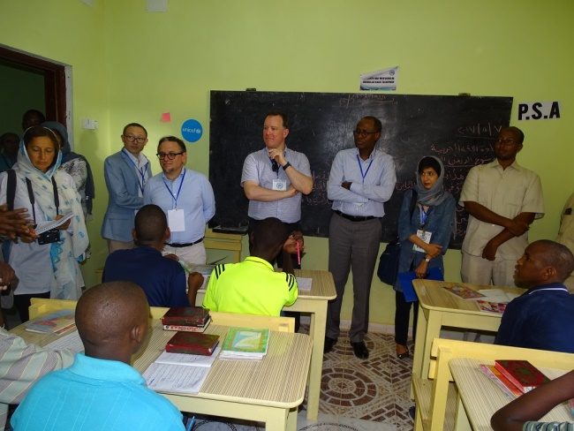
Conducted NFE Literacy, basic ICT literacy and LSBE training Classes for 40 youth under CAAFAG programme:
The children were trained on NFE, the instructors used 12 hours in a week to teach the beneficiaries on the courses, this included revisions classes based on the results of the subsequent examinations, on areas that exam showed there was weakness in understanding, the children were given remedial classes and the attendance within the period was encouraging, the youth can now flawlessly read and write Somali and Arabic languages, also they have knowledge about science and health, evaluation on all the courses learned were done through monthly and quarterly exams, and the results were so encouraging, it shows a lot of improvement and there was a general outstanding improvement.
The courses provide learners with a good insight into learning key life skills, literacy and numeracy skills by building and enhancing literacy and numeracy skills using practical examples throughout the course, the course covers a range of modules and provides multiple examples for assessment.
Regarding LSBE, 40 children were trained on life skills based education (LSBE) and were given knowledge of how to tackle extremely complicated challenges in their lives; furthermore we introduced different concepts and terminologies of life kills, values identities and how all these parameters influence our everyday lives, including roles of young people in the community and participation of young people in social set ups. The main skills covered included communication skills, decision–making, critical-thinking, emotions management, assertiveness, self–esteem, peer pressure, Self-awareness, Self-control, conflict resolution and negotiation and relationship skills. Additionally, it addressed the important issues related to empowering girls and guiding boys towards values.. We also continue to instil them with sense of peaceful and cohesive society.
- Eid day
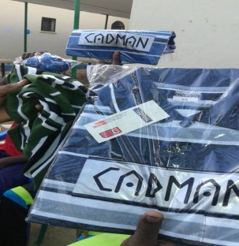
On Eid, we organized EID DAY football tournament between the children, they were put in pools where they played against each other, and the team that won was rewarded with a trophy, also as part of the celebration, the children were given new pairs of clothes.
- Hygiene and sanitation team
We organized several successful hygiene and sanitation awareness sessions with the youth, demonstrations of hand washing, water handling and safe storage was done, the team members were involved in the demonstrations and rewards were awarded to various participants who were active in question – and - answer sessions.
- National Independence Day Commemoration
20 adolescents under the programme took part in organizing National independent day (26 June) commemoration and they played a very important role in entertaining guests and participants through creative works by presenting songs and plays.
- Arts/Drawing team:
This team were trained on arts skills and provided with materials needed; they compiled ten interesting and captivating drawings, which are displayed on the Centre’s walls, these drawing displays what the youth think about in positive way.
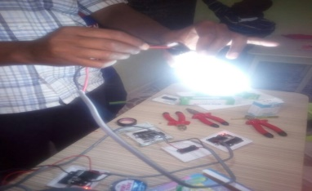
Vocational Training
As per the training regiment, in 2017, the core skills training continued as planned, Electricity, Tailoring, mobile repairing and TV installations classes were carried-out; the sessions included both theory lessons and practical sessions.
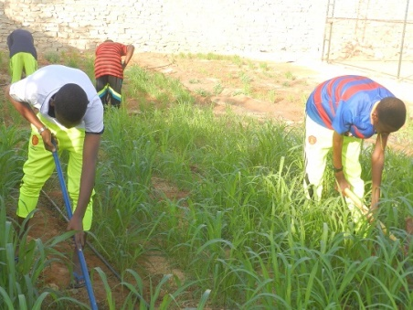
In addition, we introduced an agriculture lessons and classes after realizing that the majority of the beneficiaries came from farming background and they are affectionate and keen on farming, we introduce formation of a garden where the beneficiaries can practice their farming by planting variety of vegetables as part of improving their farming skills.
Also within the period, the children sat for their exams and the results showed great improvement, all of them passed their exams, the exams were used as evaluation on the courses taught and it indicates the objective of the programme is being met.
Lastly, we have already purchased the start-up kits and we will distribute to the beneficiaries after the end of the project.
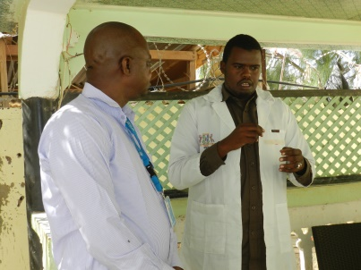
Medical check-ups and referrals
Within the period, a doctor visited the centre twice a week and conducted medical checkups and awareness on various ailments, where in all occasions he distributed the medicines, we also did medical referral for several children who needed a specialists, the doctor also conducted hygiene and sanitation awareness and consciousness on various sessions he visited the facility.
Psychosocial counseling for adolescents:
As a norm, the children were counseled based on their specific needs, hired psychosocial trainers who are profession in the field; they developed a program where on a day several children were taken through a counseling session on a regular basis, both morning and afternoon sessions.
All the children records are documented. This helped a lot the counselors to keep track on progress of each individual child from the time he/she was enrolled for the Y4C project. Core areas were on child’s behaviour, class performance and physical well-being were ascertained through observation and interviews.
All the children were given psychosocial counseling; the counseling were both individual and group based depending on the nature of the issues, the area that was given more focus was post-traumatic stress disorder and its symptoms. One of the noted issues is the difficulty of the youth in trusting adults; this is because of their previous experience where they were abducted from the qur’anic madrasas, schools, and farms/pasture fields, and sent to fight in wars they knew little about. Some of the children were put in a forced labour to ferry food stuff, water and ammunition to the fighters, for all these, they need deeper psychological therapy.
We also trained the youth on basic psychological support skills on how to identify and tackle psychological problems in families and communities.
In addition, part of the counseling were on stresses ranged from prolonged and unaddressed personal issues such as drug abuse, personal problems, effects of family problems and ex-gang life, through the counseling we successfully reduced troubling symptoms and created positive change in their lives.
We also trained the youth on basic psychological support skills on how to identify and tackle psychological problems in families and communities.
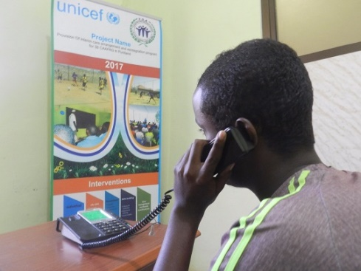
Family tracing and Re-Unifications
Within the period, we managed to invite 40 of the parents to visit the centre to check on their children, all the 40 parents turn up for the visit, they had time to talk and counsel their children on various issues and motivated them to change their destiny and be focused on their lives, we facilitated their travelling and accommodation for the visits.
Additionally, during the period we arranged phone-calls for children to talk their families and relatives and facilitated contacts to children’s families by using UNICEF Form and format, each child was given a chance to communicate to his family.
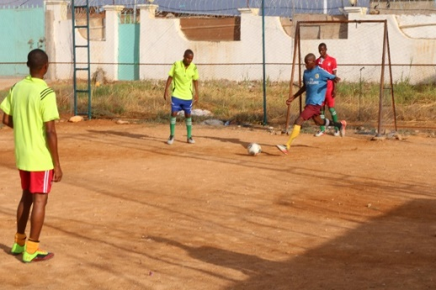
Engaged participants on recreational activities:
As always recreational activities forms an integral part of our programmes, all the children participated in different types of sports/ recreational skills (Physical Education), and every class had 6 hours per week on the time table for PE.
Also within the period, we organized EID DAY football tournament between the children, they were put in pools where they played against each other, and the team that won was rewarded with a trophy.
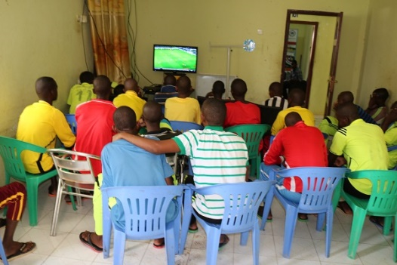
We also engaged them on quality physical education programs that are needed to increase their physical competence, health-related fitness, self-responsibility, and enjoyment of physical activity so that they can be physically active. Our Physical education programs are well-planned and well-implemented.
Furthermore, the children were trained on TV games, sports and recreational skills, the children were so interested in the recreational activities to an extend of voluntarily joining the sports session during their free time
During recreational activities Children improved their social skills, while for those in performing arts achievements were reported.
Mentorship:
We managed to organize various sessions where the mentors visited the youth and engage them in mentorship and motivation talks and discussions, these included sheikhs, community elders, leaders and successful people (business people, professionals) .These sessions were conducted to encourage and motivate the adolescent and transform them to be the beacon of hope in the community.
All the facilitators had a specific topic (Peace, Behaviour, Drug abuse, Knowledge, future, roles and responsibilities) to share with the youths within the range of their profession and experience. The aim of the mentorship clubs was to mostly encourage and motivate good behavioural change within the youths and also to encourage them to work hard and be focus in life. This has helped many of the youths in the centre where they are now always eager to learn new things every day and being punctual in their classes.
This really empowered the youths to always remember to move on and improve on their lives despite any challenge. It also proved to them through the experienced of other people that they can change their destiny and that of the community for better. We also hired a Monitor officer who to follow on mentorship clubs and the youths who were trained activities and provide help where necessary and also on their reintegration process.
The mentors also conducted child rights and gender training for caseloads, through the process, the trainers used the interactive/participatory teaching approaches rather than lecture to stimulate the learning environment in a more participatory and active way.
In addition, we facilitated child right training for community support structures, and equipped participants with the child rights and protection skills needed, which including basic knowledge on CAAFAG program.
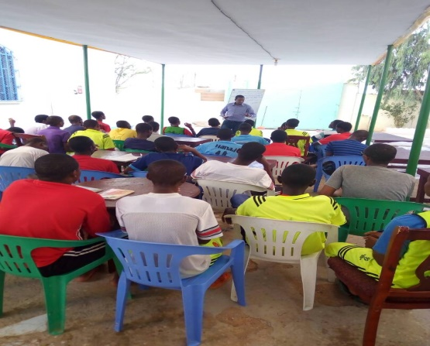
Cross-Cutting issues training
In addition, we conducted child rights and gender training for caseloads, the trainers used the interactive/participatory teaching approaches rather than lecture to stimulate the learning environment in a more participatory and active way, this was towards community support structures, where we equipped participants with the child rights and protection skills needed, which including basic knowledge on CAAFAG program
We also started provision of children’s course on cross cutting issues; they learned about peace building, conflict resolution, HIV/AIDS, environment protection and more other topics.
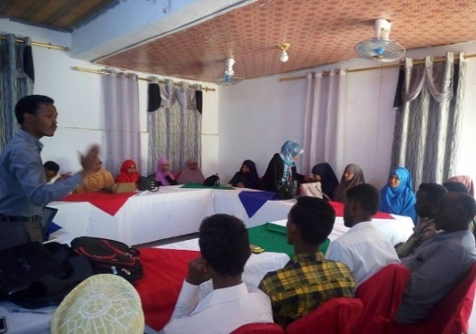
Child right training for community support structures
We formed community-based child protection mechanisms (CBCPMs) on local-level groups or processes that respond to violations against children to work prevent children from risks. CBCPMs are key parts of child protection systems since they operate at grassroots levels such as village level in rural areas and neighborhood level in urban areas, which is where children and families live and where children may be exposed to significant risks on an ongoing basis. Also, they are rich in potential child protection resources such as parents, teachers, and religious leaders, among others.
Organize advocacy campaigns for intellectuals, government institutions, and community opinion leaders
Free access to basic social services for children is essential in rehabilitation process, these calls for multi-sectoral programs and inter-agency cooperation, to create protective "child-friendly" environment for the CAAFAGS.
For this, we organized an advocacy campaigns for intellectuals, government institutions, and community opinion leaders to commit themselves to protect the children and support survivors of abuse, exploitation and neglect. They are the focal points to spot violations against children, and raise awareness about children’s rights, and help refer children and families to specialist services if needed.
We sensitize various groups to help children of war in all ways to get back to their normal lives, be it material or moral support; we did the advocacy through meetings, forums and media campaigns.
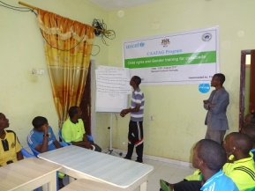
Child rights and gender training for caseloads - including the civic rights and responsibilities and nationalism
On cross cutting issues, we facilitated child right training for community support structures, and equipped participants with the child rights and protection skills needed, which including basic knowledge on CAAFAG program.
This also included child rights and gender training for caseloads; this was towards community support structures, where we equipped participants on child rights and protection skills that imperative to their day to day life, this included basic knowledge of CAAFAG program
We also provided the children’s course on cross cutting issues; they learned about peace building, conflict resolution, HIV/AIDS, environment protection and more other topics.

Gender Based Violence (GBV) Programme

FGM/C Workers Forum
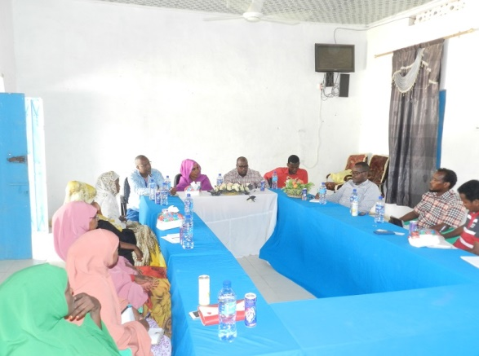
Since the establishment of FGM/C workers forum on 27 JULY 2012, we have successfully managed to hold meetings every month, the objective of the forum is to provide technical support in relation to FGM/C programming , facilitate program coordination to enhance coverage and avert duplication, information sharing and updates on FGM/C abandonment, facilitate program coordination by all key players in the zones, share updates on developments steps in the FGM/C at national and regional levels, link with Religious leaders, government protection line ministries and to spearhead FGM/C abandonment community champions at the national and regional levels.
The membership of the forum consists of UN-agencies, INGOs, LNGOs and Government ministries and departments and other relevant bodies.

16-Days activism
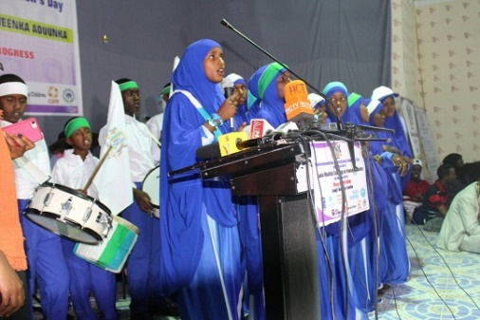
On 25th November being International Day for the Elimination of Violence against Women and it is the first day of the 16 Days of Activism. We commemorated the day with various activities to mark the start of 16 Days of Activism campaign calls that highlights that violence against women is a fundamental violation of human rights and calls for action against one of the world’s most persistent violations of human rights especially on violence against women, the campaign lasted up to 10th December 2017. .
In Somalia, violence against women continues to occur at an alarming scale. Too often it is accepted as normal behavior and the culture of discrimination against women allows violence to occur with impunity, these calls for various interventions to curb the vice.
As an organization, yearly we commemorate the day by speaking out against women’s rights abuses, as PSA we also use the occasion to raise awareness about gender-based violence as a human rights issue at the local, national, regional levels, to strengthen local work around violence against women, establish a clear link between local and international work to end violence against women, providing a forum in which organizers can develop and share new and effective strategies, demonstrating the solidarity of women around the country against violence against women and to pressure governments to implement promises made to eliminate violence against women

Livelihood

Global Entrepreneurship Week (GWE)
On November 22nd, 2017, we attended the Global Entrepreneurship Week (GWE) event at one of Puntland State University. It was attended government ministries, organizations, business community, entrepreneurs, youth, Local and International NGOs and other stakeholders that deal directly or indirectly with youth issues.
Global Entrepreneurship Week is a celebration of the innovators and job creators, including start-ups that bring ideas to life, drive economic growth and expand human welfare. During one week each November, GEW inspires people everywhere through local, national and global activities designed to help them explore their potential as self-starters and innovators. These activities, from large-scale competitions and events to intimate networking gatherings, connect participants to potential collaborators, mentors, and even investors—introducing them to new possibilities and exciting opportunities. Millions who had never before considered launching their ventures soak up advice and inspiration from the likes of Richard Branson, Michael Dell and Muhammad Yunus.
Event Objectives
- TO INSPIRE
    - Introduce the notion of entrepreneurial behavior to as many people who otherwise might not have considered it as a path in their life.
- TO CONNECT
    - Network people national wide to find new ideas at the intersection of cultures entrepreneurship & creativity
- TO MENTOR
    - Enlist active and inspirational innovators Garowe to coach and mentor the next generation as they pursue their entrepreneurial dreams.
- TO ENGAGE
    - Demonstrate to opinion leaders and policymakers that entrepreneurship is central to a nation's economic health and culture and to provide opportunity to learn from each other on entrepreneurial policy and practice.

2.3 Health

IYCF/EXCLUSIVE BREASTFEEDING PROJECT
In 2017, we implemented an ongoing project Infant and Young Child Feeding (IYCF) project which is on exclusive breastfeeding, the goal is to develop capacity of the local community on optimal infant and young child feeding practices and create mass awareness through orientation and campaigns at all level of Bosaso between August 2017 and July 2018.
Mapping and identification meeting
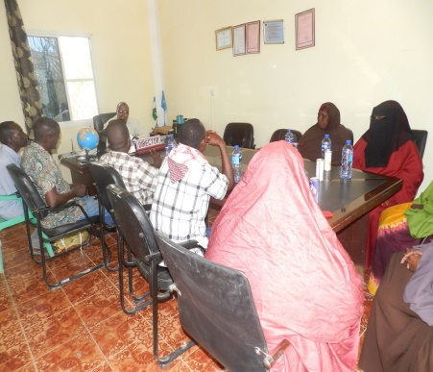
Through the initiative all the participants from all the IDP camps and villages in Bosaso were able to understand and appreciate the project’s goals and objectives in detail with the entire cross cutting issues associated with it being deliberated and explained in detail, in addition through the meeting the 9 villages with high prevalence of youth at risk were identified and prioritized.
The participants also drafted and agreed on the selection criteria to be used and selecting the beneficiaries and urged that all areas should benefit from the projects and a timeframe for registration was agreed upon.
Launch of the Project and meeting with the stakeholders
The key objective of the ceremony was to brief and update the stakeholders about the project and also to strengthen cooperation and seek the unequivocal support.
The launching ceremony was held in Bosaso, Puntland, Somalia and was attended by all of our stakeholders including local administration, targeted villages/IDPs, elders, Sheikhs, youth representatives, regional coordinators of MOS, MOE, MOWDAFA, MOLYS and other organizations.
Orientation for community committees (community gate-keepers) and recruitment of staff
During this reporting period, many milestones were achieved, we managed to develop a detailed program’s work plan, program check list & risk register and recruitment plan, where we recruited 5 of project’s staff that will ensure the project’s goals and objectives are attained within the stipulated timeframe, this included BCC officer, IYCF counselors (nurses), MOH Bosaso district supervisor and nutrition specialists. Also the community selected 10 CBW workers from their respective localities based on the criteria we stipulated to them.
Additionally, we held a meeting With MOH, ministry of women and family affairs (MOWDAFA), Bosaso municipality, IDP focal Points-MOI and MOH, where we informed them and updated them on the new project’s objectives and its expected outputs, including the modalities of its implementation and the support we require from them.
More so, we mobilized communities of the respective targeted villages and visited the villages in person where we held briefing meetings with them and discussed various issues, we also held a separate meeting with IDP gate keepers where urged them to nominate peer-support mothers as per the criteria that we outlined to them, eventually, they Selected 22 of Peer-support groups mothers.
Furthermore, later on, we held and orientation meeting where it was attended by thirty one (31) participants, this included the local authorities, focal points and village committees, we used the meeting to highlight project’s objectives to them, the ministry of health and UNICEF representatives also outlined the projects goals and merits to the participants, the meeting was imperative because we got a chance together with our partners to sensitize the local community on breastfeeding and its support mechanism, breast-feeding in regard to Islam religion, new strategies on how to make breastfeeding popular among communities and also we had an opportunity to develop district level plan to encourage breastfeeding among the families in the region. The participants were very supportive of the initiative and they promised to support it unequivocally.
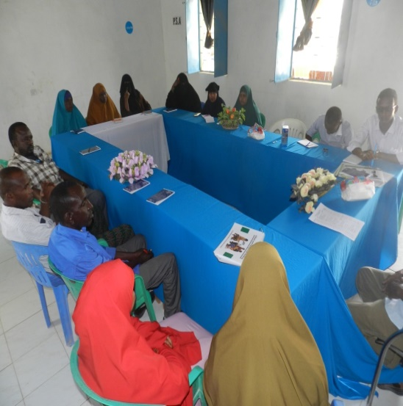
Trainings
On training, we facilitated training of Mother to Mother support peer groups, for 3 days from 9-11 September 2017, in total 22 mothers selected across IDPs communities took part and they were educated and trained on their roles on IYCF program, they promised to effectively play their roles in their respective localities.
Additionally, we conducted training for community based workers as IYCF Counselors, the training also lasted for 3 days, a total of 12 participants took part in the training, they comprised of10 CBW’s, 5 supervisors, 2 nurses, 2 facilitators, 3 government representatives (MOH & city councils).
Furthermore, we trained 18 promoters, campaigners and proponents, two promoters for each location, their scope and mandate was to organize promotion sessions and participate in house to house visits and give support mother to mother peer groups.
Lastly, the nurses that were hired for the programme received one day training on breastfeeding in line with the project’s implementation by the ministry of health (MOH) and further five (5) days training by UNICEF in Garowe.
Establishing and equipping mother baby friendly areas to provide skilled IYCF services
In the Ten (10) IDPs camps under the IYCF project, we established Mother-Baby Areas (MBAs) where counseling is done and also as a dedicated space/room provided for breastfeeding mothers who have come for consultation to breastfeed in privacy.
The areas are also equipped with necessary materials, including mats, toys and other necessary items.
Promotion and sensitization campaigns
In order to achieve maximum penetration of messages on breastfeeding and build an enabling environment for the programme, awareness generation and advocacy activities, we designed and printed leaflets, T-shirts, posters, banners and billboards, the messages that were printed on the materials were translated into Somali language, so that it can be fully understood by our target audience and groups, later on the IEC materials were distributed to all the target areas and fixed on all appropriate areas including sticking them on cars, MCH, hospitals, community centres, schools, tea shops and Markets, we also erected the billboards at the sites.
Additionally, on outreach, we compiled and formulated media messages and released them to TV/radio talk shows (aired twice in a week), the messages reached extensive audience both directly and indirectly, it also included awareness raising meetings in all nine targeted locations, the main topics covered were awareness on exclusive breastfeeding for the first 6 months, complimentary feeding after the sixth months, the importance of feeding on balanced diet to expecting mothers and lactating mothers, information on locally available nutritious food, referral mechanism for malnourished children and problems associated with bottle feeding.
As a model of motivation, we distributed baby gifts hampers, clothes, hygiene promotion kits and toys, the materials were given to mothers that attended MBAs.
Also, we trained promoters, campaigners and proponents, two promoters for each location were mandated to organize promotion sessions and participate in house to house visits and give support mother to mother peer groups.
More so, within the month, we organized several promotion sessions, where we used portable wireless amplifier radios to reach as many people as possible, during these sessions participants engaged in fruitful and robust debates/discussions.

Counseling
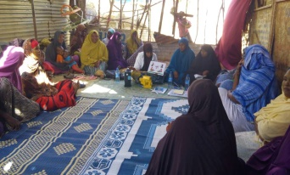
On counseling, we held a total of twenty four (24) group counseling (mother to mother support group) sessions in MBAs which benefitted 331 persons (247 F & 84 M) and individual IYCF counseling for pregnant women and lactating mothers, which reached 503 persons (223 mothers with infants 0 to 6 months of age, 181 mothers with children 7 to 24 months of age and 99 pregnant women).
To make the Programme more effective in achieving its goal, we advise and counseled the mothers on priority areas such as: early initiation of breastfeeding and ‘no’ to prelacteals and water; myth of not enough milk; emotional and overall support to the lactating mothers; advocacy with gatekeepers such as mother in laws/husbands and other family members to support breastfeeding; information on where to go in case of difficulty in breastfeeding; breastfeeding in case of working mothers; and ill effects of infant milk substitutes.
In addition, we also advise the mothers on optimal feeding and care practices, for instance the optimal use of locally available foods, strategies to improve availability and affordability of quality foods.
Also, at each counseling session contact, we asked the lactating mothers asked about their emotional wellbeing, what family and social support they have and their usual coping strategies for dealing with day-to-day matters. We also encourage both families/partners to give them full support during the period.
We also counsel the women on nutrition and their hygiene, especially hand-washing and general wellbeing of them and their general family as a whole.
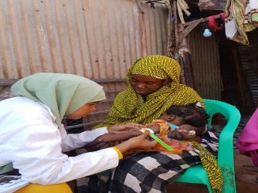
MUAC screening
facilitated MUAC screening and made referrals to other centers including OTP, MCH and SFP, also due to delay in delivery of supplies, we made follow ups to UNICEF, the supplies comprise of multiple multi-nutrient tablets and MNPs, fortunately in the last week of October UNICEF delivered the supplies to us.
During the period we screened:
- 1004 under 5 children with MUAC and 459 of them were referred to the appropriated health facilities
- 582 pregnant women and 179 of them were referred to the health facilities

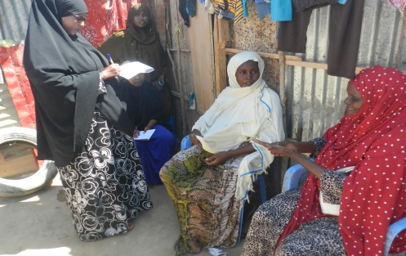
Monitoring and supervision
Firstly, as part of pre-evaluation survey, we did assessment on MBAs will be part of our ultimate assessment planned at the end of the program to ascertain impact of the program which will also include post-evaluation survey.
Also, we conducted home visits and also joined mothers at the MBAs, during the home visits, we got a chance to observe and monitor hygiene and sanitation situations in homes/families, we also assessed if there were malaria, measles, mal-nutrition and other cases that needed intervention.
In addition, we developed IDPs camps visits plan, the plan gives details of planned visits by nurses and supervisors in terms of schedule, it also indicates CBW for each targeted IDP, the visit plan also point out mothers-supports groups roles and responsibilities in facilitating communication and monitoring, project officer also is required to visit the sites twice a week.
Furthermore, we did periodical monitoring to ascertain if all activities were rolled out as per the prescribed standard operating procedures or if there were cases of code of violations in our media messages and in our other activities, we did this through seeking views and thoughts of those who our messages and campaigns reached them.
Also we conducted joint monitoring with MOH through supervision of MBAs centres, interviewing mothers at the MBA centre, home to home visits supervision, group/individual counseling sessions supervisions, meetings with IYCF staffs and sought their views on the gaps they feel they needed more assistance.
The result of the joint monitoring confirmed that the performance of all IYCF MBA centers and nutrition sites were good except the shortage and delay of supplies for some nutrition sites.
We also made follow up on the supplies from UNICEF, which has delayed as per the timeframe agreed upon, the supplies comprise of multiple micronutrient tablets and MNPs.

World’s Aids day

On World AIDS Day, which we yearly commemorate on December 1 each year, we dedicated it to raising awareness of the AIDS pandemic caused by the spread of HIV infection.
PSA In collaboration with its partners coordinated a number of HIV/AIDS awareness activities within Bosaso. We did awareness-raising through streets matching, media coverage, forums, ceremonies and IEC materials distribution.
Hosting the event reminded the public that HIV continues to be a global challenge and collectively, there is a need to increase awareness, fight prejudice and advocate for support in puntland state and nationally.
There were also speeches from various participants on awareness necessity, we urged every attendant to use every opportunity on fight against HIV, show support for people living with HIV and remember those who have died. Key speakers engaged with a mass audience regarding milestones in the fight against HIV and AIDS and pervading challenges.
PSA firmly believes that the future generation has the ability to sensitize others and prevent spread of HIV. We also held an interactive session on HIV and AIDS with residents of Bosaso, Mr. Abdi Hassan was the resource person. She emphasized on HIV transmission, staging, stigma, prevention, treatment, and role of nurses in overcoming stigma and discrimination.

2.4 Capacity Building

Youth Leadership Capacity Building

On 9th August 2017, PSA hosted a multitude of different diversity building events for youth.
The event focused on leadership building, anti-violence workshops, diversity/multiculturalism training and youth employment and related information sessions. Also career exploration session was delivered to help youth develop their life and job skills to ease their transition to social integration and work.
The Youth Leadership Program’s successes were training on barriers that affect youth engagement through knowledge and experience sharing, youth leadership capacity building as way of promoting diversity and in assisting the creation of caring, welcoming and inclusive communities, social cultural interaction among youth from diverse backgrounds, understanding of opportunities for meaningful youth engagement in communities’ decision-making process and decreasing inter-generational conflicts and gaps

Staff capacity building
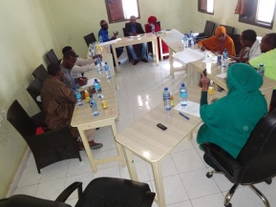
On 9th - 14th of December 2017, PSA held a staff training programme for its staff on various areas as per Board of directors meeting recommendations, the areas covered were report writing skills ( contents, summary, body, lessons learnt, recommendations and conclusion, Success story ( Title/topic, body, conclusion), Filing system ( office administration, filling system, numeral filing system, conventional/non-conventional records, record cycle, computer assisted records and check list, good office administration and filing problems) and logistics: (safe guarding assets, asset registration, equipment maintenance, vehicle e policy)

Monthly Youth Forum
Youth Forum is a dynamic, community-based discussion group made up of diverse youth and adults, working together meeting monthly to support youth services and build strong community assets for healthy youth and families. This program helps youth and local adult leaders to come together in a safe space to communicate about important issues and form connections to build up the positive youth network.
Youth Forum at PSA is now in its 2nd year and we couldn’t be prouder of the work that has been accomplished at this period. Throughout the last one year, discussion generated at Youth Forum has brought a number of exciting and needed initiatives and services to the youth and families of our communities such as school clubs, crime prevention initiatives, school enrollment programs and community service initiatives.
We believe that young people can make a difference to the world, so the main aim of our Youth Forum is to provide local children and young people with a platform to have their voices heard.
We aim to foster a friendly, open and welcoming setting to help empower the young to take a more active role in decisions that affect themselves and their community.
We provide training and support so that young people can feel confident to participate in the decision-making process affecting them both now and in the future.

2.5 Micro-Assessment

As a measure of transparency and accountability, external auditing is requirement and compliance necessity. A micro assessment exercise for PSA was done on 26th September 2017 at our main offices in Bosaso by external auditors on behalf of UNICEF. The exercise involved among other procedures, an interview session with key staff members, this was in order for the auditors to understand our systems and processes, review our policies and procedure documents, verification of sample support documents and physical verification of selected assets, the exercise ensure an accurate and unbiased assessment of our organization’s procedures, systems and internal controls was ascertained.
We offered all the required assistance that they required to complete the micro-assessment. Upon the conclusion of the micro-assessment exercise, both PSA and UNICEF were provided with a copy of the report.
Additionally, as a result of UNICEF and other UN Development Group agencies adopting HACT (Harmonized Approach to Cash Transfers), which is a common operational framework for transferring cash to government and non-government Implementing Partners. We trained our staff on its modalities and procedures aiming at reviewing partners financial and programmatic management capacity, including accounting, procurement, reporting and internal controls. The purpose of the micro-assessment was to review our strengths and weaknesses and how to adopt appropriate assurance methods, and best procedures to use for transferring cash.

2.6 Advocacy Programme
Advocacy is a cornerstone of many NGOs. At PSA, we have endeavoured to advocate for policy legislation to bring about better social-economic and human rights conditions for vulnerable persons. PSA joined other non state actors as well as government departments to commemorate events as an awareness raising and advocacy strategy. There were 6 commemorations and they are reported on here:

Somalia Independence Day Commemoration
Somalia gained its independence on 1st July and every year the day is marked with pomp and color and fanfare. This time around on this day, with the help from PSA, our youth commemorated the day with immense joy, fanfare and magnificence. They participated in a series of thematic activities, namely; songs, poems, questions crowning the day with a scintillating theatrical performance alongside the singing of the Somalia national anthem. The stellar show received a standing ovation from all the participants. The latter were later served with snacks and drinks.

Somali National Youth Day Commemoration
The International Youth Day is observed all over the world and Somalia was not left behind. Puntland Youth and Social Development Association (PSA) organized a colorful event where we invited schools and college students. The day was marked with processions, speeches, recitations, music and youth presentations and recitations, study circles and community service projects involving the youth.

Establishment of Puntland state (1st August) Commemoration
On 1st August we joined the citizens of Puntland state in celebrating and marking the 17th Anniversary since Puntland State was established. The event was attended by youths, students, parents and members of the public. The participants were entertained by the Youth for Change (Y4C) children who presented songs, drama, poems and dances to mark this emotional day.

Eradication of violence against women day (25th November) Commemoration
The 25th November is international day for the eradication of violence against women. During 2015, Youth for Change (Y4C) beneficiaries organized a small event in which they presented their views on how they think and feel women and girls should be protected from the vice. They expressed themselves on how violence affects women/girls through speeches, poems, skit drama, paintings and drawings. In all, the objective of strengthening the prevention of violence against women and girls and promotion of effective and rapid response to it was achieved.

International Women’s Day Commemoration
Celebrations for this international day have always been championed by MOWDAFA. Like all such days, it serves to highlight the importance of the theme of the day-in this case women's rights. PSA is glad to report of its participation. International Women's Day (IWD), originally called International Working Women’s Day, is marked every year on 8th March. In the different regions, the sub themes of the celebrations ranged from paying homage, appreciation and recognition of outstanding women in economic, political and social achievements. This will continue as the need to empower women and eliminate discrimination against them is only beginning.

Human rights day Commemoration
The 10th December being Human Rights Day, PSA commemorated the day by engaging members of the public in dialogue on human rights violations and promotion in the country. The participants were mainly youth and various stakeholders which included government officials and many of our partners.
The total number of the participants was 205 and our human rights team used the occasion to educate and sensitize the participants on human rights issues. We reminded the participants that everyone has internationally recognized fundamental rights regardless of their clan, age or gender and their observance was an obligation to us all. We also educated them why they have to respect and value other people's rights as well and not forgetting that patriotism, nationalism, good governance and freedom of assembly all encapsulate respect of universal human rights and tolerance for one another. The event was fully covered by the media and testimonies from various stakeholders were well documented. SBC, Radio Dajlir and Radio Batur are among the stations which featured documentaries about PSA activities.

2.7 Media

The use of social media tools such as Facebook, You Tube, twitter and blogging sites have become part of the daily lives of thousands of people in Puntland and Somalia in entirety. Youth is the world’s fastest growing and largest segment of social network users in the world. Around the globe, social media tools have helped fuel social movements. Social media has been shown to strengthen social actors’ ability to challenge and change way of life in relation to society, providing platforms for debate, reflection, influencing and mobilizing people. To better understand the potential of social media we engaged young people in efforts to prevent illegal immigration designed to raise awareness and motivate young people to take action to prevent the practice. The engagement revealed practical lessons on the effective use of social media tools for violence prevention.
In the month of April 2017, after more than 400 migrants who were largely Somalis migrants, drowned in the Mediterranean while trying to cross by boat from Egypt to Italy, PUNTLAND Youth and Social Development Association (PSA), conducted massive online awareness and sensitization through Facebook on the illegal immigration risks and dangers. The objective was to sensitize and educate the youth on the dangers and risks that comes with illegal immigration. The youth also got the opportunity to air their opinions, views and recommendations on how to curb the menace.
The specific objectives of the initiative were to engage community members to take up the issue and become activists themselves against illegal immigration, personalize the process by reflecting that each person can be a part of the solution, frame the illegal immigration problem as a community’s responsibility, not as individual problems, provide an opportunity for the community leaders to share their experiences and recommendations on how to address the issue of illegal immigration, capturing good practices, challenges and support needs, with particular reference to key areas in respect to stop the practice and personalize the process by reflecting that each person can be a part of the solution;
From the participant’s feedback, it indicated that the objectives were achieved. Appreciation was expressed in particular from the views and comments made by the participants online, an array of solutions were suggested and the participants promised to take the matter personally.

LESSONS LEARNT
Community consultations in planning and implementation continues to bear fruits, it inculcates the sense of ownership to the local community. This is good for sustainability as community structures of children, youth, women and other vulnerable persons will sustain the activities long after project’s implementation phase. The country is recovering and communities are developing mechanisms to be more resilient, still the need for NGO support is big given the inadequate services from government.

CHALLENGES
In 2017, one of the major constraints was overwhelming demand for our services despite the inadequacies in funds. There are many community interventions needed by the local communities but we can do little given the budget limits provided by our donors.
In addition, staffs notwithstanding their determination and dedication reflect some gaps in capacity building. It is our intention to strengthen our institutional capacity through in-service on job training.
Furthermore, security is still a challenge in most parts of the country including Puntland with abductions and other terrorist acts reported almost monthly. These are issues which the authorities will be lobbied to explore best options.

CONCLUSIONS AND RECOMMENDATIONS
As PSA, we have the strongest assurance that our activities continues to change and transforms lives across our areas of operation in Puntland region, more so the youth, together with our donors and partners we plan to roll out many life-changing projects in 2018. It is our plan to hold a strategic planning exercise to assess where we have come from, where we are and where we are going in a specific timeline. This may impact on our focus and scale of operations. Whatever we will agree on will be in the best interest of the community.
We will always be indebted to our donors and partners in aiding all of our operations and making sure that our projects are successfully implemented.

