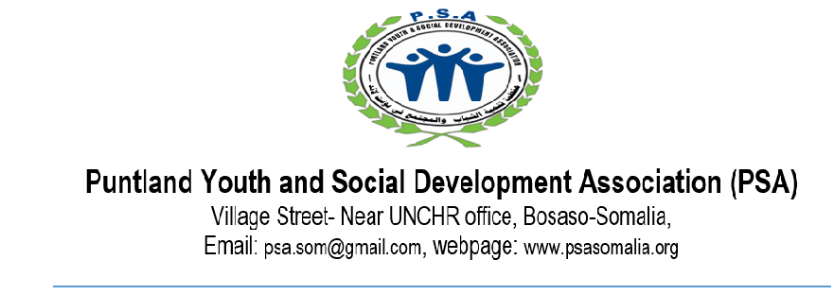

Ethical conduct from our potential suppliers:

- Zero tolerance
PSA have zero tolerance have zero tolerance policy on:
- Child abuse
- Sexual exploitation and abuse
- Unsafe, illegal, or unethical working practices
- Violence and aggression
- Discrimination, bullying and harassment in relation to ethnicity, sexual orientation, gender, nationality, colour, religion, age, disability, gender, marital status, or political affiliation
- Fraud, bribery, and corruption
- Retaliation against whistle blowers who speak up and do the right thing

- Rule of law
PSA upholds the highest standards in the manner with which it runs its operations, particularly in respecting human rights, labor laws, and the environment. You are required to abide by the rule of law as may be stipulated in any legislation that governs the land and such other laws as may be deemed applicable while engaged with PSA.

- Labour
- Forced or Compulsory Labour - PSA expects its staff and suppliers to prohibit forced or compulsory labour in all its forms.

- Child safeguarding PSA has a zero-tolerance policy to child abuse and sexual exploitation of children by our staff, associated personnel, partners and contracted goods and service providers . All children aged under 18 years have equal rights to protection from all forms of violence as declared in Article 19 of the United Nations Convention on the Rights of the Child.

- Health and Safety: PSA expect staff and suppliers to ensure, so far as is reasonably practicable, that: (a) the workplaces, machinery, equipment and processes under their control are safe and without risk to health and where necessary, adequate protective clothing and protective equipment are provided to prevent, so far as is reasonably practicable, risk of accidents or of adverse effects to health.

- Conflict of interest
Each employee and service providers should avoid any situation where objective judgment, or behavior concerning a primary interest from being improperly influenced by a different interest which such as, but not limited to, financial gain or his/her immediate family, close relatives or personal friends. All the staff and service providers will be require to declare such interest and inform the immediate supervisors.

- Corruption and Money Laundering
PSA prohibits any pay for, offer, or grant unwarranted advantages, in any form whatsoever, directly or through an intermediary, to a private party or a representative in public authorities anywhere for purpose of obtaining favorable treatment or influencing the outcome of a negotiation with individual or organization.

All the organization staff and service providers are prohibited in their capacity while engaged in the organization to participate in any activities within the definition of any local and international law construed to me money laundering. PSA has a ‘whistleblowing procedure’ for staff members and any other concerned parties to raise a concern confidentially outside of the reporting lines outlined in the PSA Grievance Procedures. All staff and service providers must report any incident relating to fraud , corruption and money laundering.

- Procurement Ethics
PSA procurement must be conducted according to laid down procedures designed by the organization. All processes must be handled in an ethical manner, with total impartiality, and without any preferential treatment. All staff and suppliers must ensure procurement principles are not compromised and at all times observe the following practices;
- Avoid conflicts of interest, ensure impartiality and fairness
- Exercise due diligence
- Respect for rules and regulations;
- Integrity
- Transparency
- Confidentiality
- Avoidance of impropriety
- Due diligence.

- Sexual Exploitation and Abuse Clause
The following specific standards of behavior apply to all PSA personnel including staffs, volunteers, interns and consultants - while under collaboration with PSA and at all times, this includes both within working and outside of standard working hours. All PSA personnel must adhere to PSEA standards and values. These standards are as follows;

- PSA personnel must not request any service or sexual favor from beneficiaries of our programs or other members of the communities in which PSA works in return for protection or humanitarian assistance, and must not engage in sexually exploitative relationships.
- PSA personnel must not exchange money, employment, goods or services for sex, including sexual favours or other forms of humiliating, degrading or exploitative behavior. This prohibition against exchange of money for sex means that PSA personnel must not engage the services of sex workers while on PSA assignment, including in PSA premises or accommodations, and while travelling to/from or attending meetings, workshops and trainings, regardless of the local or national law concerning sex work or prostitution in the country in which they work.
- PSA personnel must refrain from having sex or engaging in sexual activity with beneficiaries because there is an inherent conflict of interest and potential for abuse of power in such a relationship. If a personnel member has sex or engages in sexual activities with a beneficiary, he/she must disclose this conduct to his/her supervisor. Failure to report such a conduct will lead to disciplinary action.
- PSA personnel must refrain from sexual activity with any person under the age of 18, regardless of the age of majority or age of consent locally, i.e. the local or national law of the country in which they work. Ignorance or mistaken belief of the child’s age is not a defense. Failure to report such a conduct will lead to disciplinary action.
- PSA personnel must not support or take part in any form of sexual exploitative or abusive activity, including, for example, pornography or trafficking of human beings.
- PSA personnel must report in a timely manner any concern or suspicion they have regarding possible violations of the PSEA Policy and related standards of behavior via PSA established reporting procedures. PSA personnel must report any concern or suspicion regarding sexual exploitation or abuse via PSA established reporting procedures even when the alleged perpetrator is another humanitarian aid worker. Information related to SEA incidents involving PSA personnel or associates, or other humanitarian aid workers, must be shared only with the in-country PSEA Focal Point or his/her alternate who will take over the case and inform immediately the in-country PSEA Referent to discuss the way forward.
- PSA personnel must create and maintain a living and working environment which prevents sexual exploitation and abuse, and promotes the implementation of the PSEA Policy

STATEMENT OF COMPLIANCE
Any violation of these standards constitutes serious misconduct. Failure to comply with these standards or failure to report sexual exploitation or abuse is grounds for disciplinary action. This action may include termination of contract or summary dismissal, and may result in the case being forward to the local authorities for criminal prosecution where appropriate and in accordance with applicable laws.

I, the undersigned hereby declare I will adhere to the code of conduct as stipulated here in undertaking my engagement pursuant to my contract with PSA.

Name __________________________________

Signature of the Service Provider: ______________________________

Date: __________________________________

