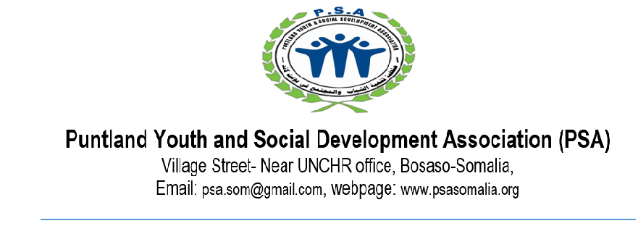
Date: 14 Mar 2023
INVITATION TO BIDS
BACKGROUND
Puntland Youth and Social Development Association (PSA) is a local non-governmental, non-profit organization established in 2002 by a group of enthusiastic young educated members of society and is based in Puntland State – Somalia.
PRODUCTS/SERVICES REQUIRED
PSA is currently seeking bids for the Building Materials.
BID Number | Product/Service | Location
BID-PSA/0737/2023 | Timber Wood 2/2 (Alwaax 2/2) | Bosaso
BID-PSA/0737/2023 | Timber Wood 2/3 (Alwaax 2/3) | Bosaso
BID-PSA/0737/2023 | Metal Sheet (Jiingad) No.32 | Bosaso
BID-PSA/0737/2023 | Timber Nails #6 (Masaamiir #6) | Bosaso
BID-PSA/0737/2023 | Timber Nails #10 (Masaamiir #10) | Bosaso
BID-PSA/0737/2023 | Concrete Iron No.12 (Birta Shubka) | Bosaso
BID-PSA/0737/2023 | Pipes (No.4) | Bosaso
BID-PSA/0737/2023 | Cement (Shamiito) | Bosaso
BID-PSA/0737/2023 | Hinges (Faseexado) | Bosaso
BID-PSA/0737/2023 | Door Locks (Qataar ama Handaraab) | Bosaso
BID-PSA/0737/2023 | Lime (Nuurad) | Bosaso
BID-PSA/0737/2023 | Lime glue (Koolada Nuurada) | Bosaso
BID-PSA/0737/2023 | Bricks (Bulukeeti) | Bosaso
BID-PSA/0737/2023 | Construction sand (Niis) | Bosaso

Instructions to suppliers

- You are requested to visit PSA Office in Bosaso to pick the relevant templates for the bids or call 0907754033 to request soft copies to be sent through email. Any inquiries can be done through the same contact provided.
- Ensure the bids are submitted using the specific forms for the products/services interested to offer.
- Suppliers must be financially stable. Suppliers should undertake to provide the organization with unlimited services and goods for not less than US$ 20,000 without no payment for us at least for 3 months.
- Only successful applicants will be contacted
- All the bids to be sealed in an envelope with Bid Number and include location and addressed to;
- PSA PROCUREMENT
- Head Quarter Office-Bosaso
- 0907754033
- Deadline: All the bids should be received no later than 19-Mar-2023 at 5:00 pm.

