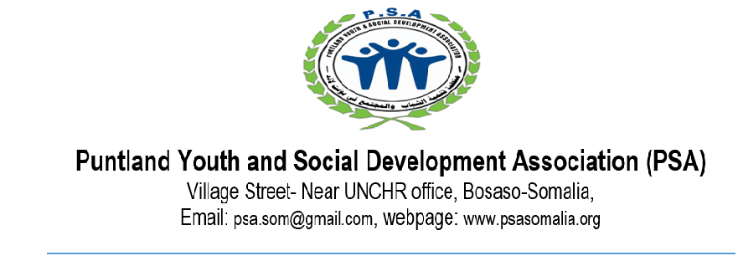

**SUPPLIER DECLARATION FORM**

**Ethical conduct from our potential suppliers:**

Apart from the social standards outlined below, we demand ethical conduct from our potential suppliers in the procurement process. The following practices are intolerable and co-workers proven to be involved with such activities may have their employment terminated with immediate effect:

* **Corruption:** deliberately promising or giving an advantage to a person in order to influence that person to act in a specific way or to refrain from acting in accordance with his/her professional duty
* **"Corrupt practices"** may also be interpreted to mean, soliciting or accepting, directly or indirectly, gratuity, gift, favor, entertainment, kickbacks, commissions, employment or promise of employment to self, family and relatives, or things of monetary value from anyone.
* **Collusion:** the active or tacit co-ordination of potential contractors’ competitive behaviour, with the likely result that prices rise, output is restricted and the profits of the colluding companies are higher than they would otherwise be (e.g. price fixing agreements).
* **Coercive practice:** threats or harm of persons are made in order to influence procurement processes.
* **Fraud:** the use or presentation of false, incorrect or deliberately incomplete statements and documents. It can also mean the misapplication of funds for purposes other than those for which they were originally intended.
* **Sexual Exploitation and Abuse Clause:** PSA is fundamentally commitment to gender protection and the prevention of sexual exploitation and abuse. PSA suppliers are prohibited from engaging in or facilitating any form of inappropriate relations, sexual harassment and sexual exploitation in particular involving beneficiaries, any supplier who fail to observe this clause will cease to work with PSA immediately and will never transact any business with PSA.
* Any of the above conduct by a supplier results in the rejection of its offer and the termination of existing contracts. This should also be stated in all relevant bidding/tendering and contractual documents. Furthermore, potential contractors must certify that none of the following applies to them:

**DECLARATION**

I DECLARE THAT THE INFORMATION PROVIDED ABOVE AND ALL THE ANNEXES IS COORECT AND THAT NO PERSON IN ANY CONNECTION WITH THIS ESTABLISHMENT, AS SUPPLIER FOR PROVIDING MATERIALS, SUPPLIES OR SERVICES OR AS A PRINCIPAL OR EMPLOYEE, IS EMPLOYED BY PSA, OR BARRED BY PSA.

**NAME: __________________________________________**

**POSITION: ____________________________**

**DATE: __________________**

**SIGNATURE AND STAMP: ______________________**