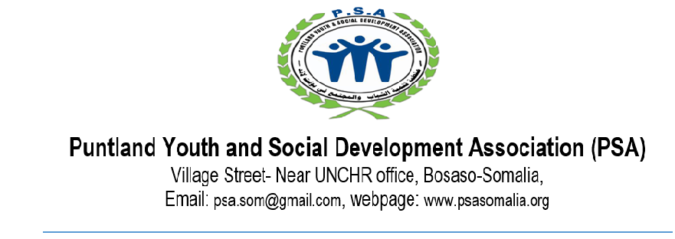
TERM OF REFERENCE (TOR) ON PEACE BUILDING WORKSHOP FACILITATOR
Date: 13th March 2025
About PSA
Puntland Youth and Social Development Association (PSA) is a non-profit organization established in 2002, dedicated to promoting social-related activities and peacebuilding initiatives in Puntland, Somalia. PSA focuses on safeguarding vulnerable populations, advocating for human rights, and facilitating community-driven peace processes. Through partnerships with local communities, government agencies, and international organizations, PSA has played a pivotal role in fostering stability, resolving conflicts, and enhancing governance in the region. Its programs prioritize inclusivity, conflict sensitivity, and sustainable development to create a peaceful and secure environment in Puntland.
Project Background
PSA, along with its consortium partners, will implement the SSF III project in the border region between Puntland and Galmudug, an area that has historically experienced inter-communal and inter-state conflicts but is now witnessing a sustained ceasefire and increased cross-border cooperation. SSF III aims to build on this progress by supporting inclusive political agreements, addressing grievances, promoting democratic processes, strengthening local governance, and enhancing accountability between citizens and the state. The project will engage key stakeholders including the existing peace committees as well as the government in broader peacebuilding efforts to reinforce conflict resolution mechanisms and ensure their effectiveness in sustaining peace and stability.
The project will tackle several critical challenges, including recurrent inter-communal conflicts that threaten political settlements, the vulnerability of peace processes due to political divisions and external pressures, and competition over resources exacerbated by climate change. Additionally, SSF III will work to enhance early warning systems and dispute resolution mechanisms, particularly along the Puntland-Galmudug border. Recognizing the role of media in shaping narratives, the project will also address the risks posed by the proliferation of social media without adequate media literacy, which has the potential to escalate tensions.

- Scope of Work
The facilitator will be responsible for developing a comprehensive training manual designed to enhance the institutional capabilities of peace committee members. This manual will equip them with the necessary skills to organize, plan, coordinate, and effectively communicate their activities and interventions. Strengthening these capacities will enable the committees to play a more active role in public advocacy, oversight, peacebuilding, and reconciliation efforts within their communities,
As part of this assignment, the facilitator will lead an induction workshop using a qualitative methodology that encourages peace committee members to share their personal experiences of violence, through structured Focus Group Discussions (FGDs). To make the learning experience dynamic, the workshops will incorporate active participatory peacebuilding approaches, including individual and group tasks, case studies, and simulations, ensuring a dynamic and engaging learning process. Participants will be encouraged to contribute insights based on their expertise in peace, development, human rights, gender rights, and humanitarian work which will help develop the committee’s SOP. Additionally, to ensure a smooth process, the facilitator will be required to draft a detailed work plan and submit it to the PSA program team for review and input before finalizing the document. PSA program team believes that collaboration and careful planning are essential for a successful workshop.
- Duties and Responsibilities
The Facilitator will be responsible for the following tasks:
- Develop a comprehensive training manual tailored to the needs of the Peace Committees.
- Conduct training sessions on conflict resolution techniques, mediation skills, and effective communication strategies to help committee members handle disputes and foster peaceful dialogue.
- Organize role-playing exercises to simulate different conflict scenarios, enabling members to practice applying conflict resolution techniques in a controlled setting.
- Facilitate group discussions on the root causes of conflicts, the impact of conflicts on communities, and the role of the peace committee in promoting reconciliation and peace-building efforts.
- Engage in team-building activities to foster trust, collaboration, and teamwork among committee members.
- Assist in creating a strategic plan with clear goals, action steps, and timelines for the peace committee’s activities and initiatives.
- Guide the development of Standard Operating Procedures (SOPs) to ensure systematic peacebuilding efforts
- Train members on best practices for record-keeping, documenting meeting minutes, and drafting formal peace agreements to enhance transparency and accountability.
- Encourage members to provide feedback on the training sessions, share their perspectives on the induction process, and identify areas for improvement or additional training needs.
- Prepare and submit an activity report summarizing the key takeaways, participant feedback, and recommendations for future peace building initiatives.

- Qualifications and Experience
The Facilitator should possess:
- Master’s degree or equivalent in Community development, Peace and security Management, political science, sociology, or any other field related to international/human development.
- Have more than eight years of experience in humanitarian development and peacebuilding preferably in a fragile context.
- Professional experience of working in Somalia at the community, village, and district levels, with a clear understanding of traditional forms of social organization and systems of local governance, as well as official systems of local administration.
- Competence in the Somalia and English languages, particularly in writing and be fluent in both English and Somali language in region where this assessment will take place.
- Strong communication skills, with the ability to communicate detailed concepts clearly and concisely both in writing and verbally.
- Demonstrate experience and expertise in conducting similar assignments for reputable organizations.
- The capacity to deliver in the timeline outlined.
- Strong analytical and report-writing skills

- Deliverables
The Facilitator will deliver the following outputs:
- A comprehensive training manual tailored to the needs of the peace committees.
- A draft of the peace committee’s Scope of Work (SOP) and Operational Standards for peace initiatives.
- A final activity report summarizing the training outcomes, participant feedback, and recommendations for further capacity building.

- Duration of the Consultancy
The consultancy is expected to commence on 17th March 2025 and will span five days, including three days dedicated to workshop facilitation and two days reporting.
Location: Galkacyo District
- Salary
Salary will be based on qualification and experience.

